

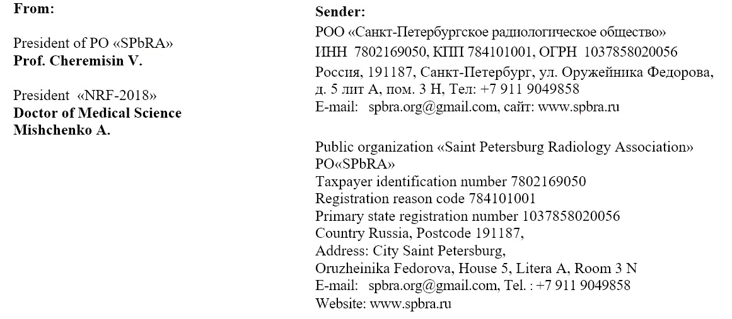

# 

# Dear _________________________________________________!

