

Региональная общественнаЯ
организация
«Санкт-Петербургское
радиологическое общество»

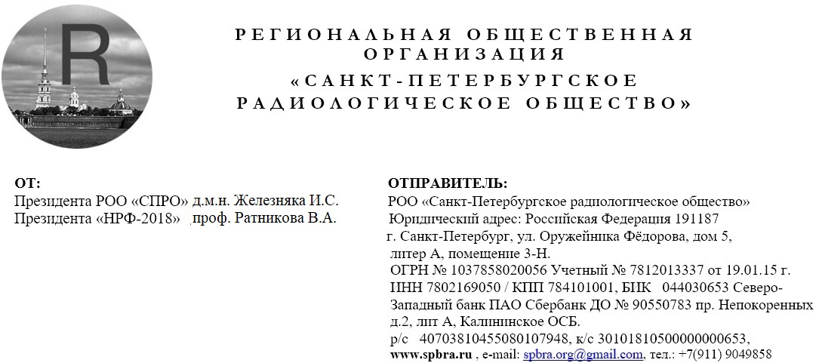
ОТ:

Президента РОО «СПРО» Железняка И.С.
Президента «НРФ-2022» Ильиной Н.А

КУДА / КОМУ:

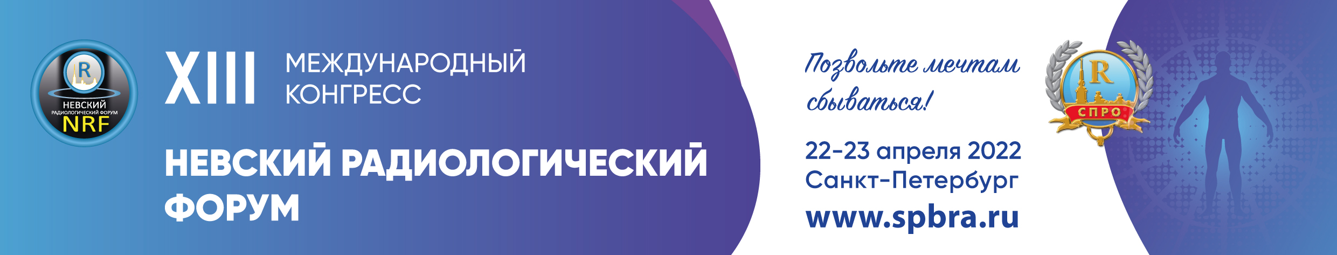

Invitation to participate in the XIII International Congress "Nevsky Radiological Forum-2022"

Dear _______________________________________________________________________!

The Public organization «Saint Petersburg Radiology Association» is making every effort to ensure that NRF-2022 once again brings together scientists in the field of radiology, radiology, hybrid technologies, ultrasound, radiotherapy with extensive Russian and international experience. The Forum is waiting for representatives of practical healthcare represented by managers and directly medical professionals, doctors, as well as young scientists who are just starting their way, clinical residents, university students and postgraduates, who are the future of science and practice!

Specialists of related specialties are also involved in the work of NRF-2022, because without mutual cooperation between doctors of radiation diagnostics, surgery, therapy, neurology, physiology and morphology, cardiology, pulmonology and others, it is impossible to fully understand pathology and its radiation characteristics, sometimes determining the choice of tactics and treatment methods. To date, our knowledge and experience show that many rare and not very rare diseases "Сome from childhood”, so much attention will be paid to sections that unite not only doctors of different specialties, but also representatives of “adult” and “children's” medicine. Childhood is a special time when you believe that everything you have planned will come true. That is why the motto of the next Forum is: "LET DREAMS COME TRUE!".

The format of the NRF-2022 will depend on the realities of the epidemiological situation in Russia. The plans of the PO «SPbRA» are to hold the forum in a classroom format with an online broadcast.
Traditionally, much attention will be paid to the organization of sections of various formats and competitive events for young scientists and graduate students, clinical residents and students. Sections for X-ray technicians are planned separately, which gather an increasing number of participants.

We invite you to participate in the preparation and conduct of the NRF-2022, indicating at registration a convenient and acceptable format of work.

The forum will also pay great attention to the coverage of new products from manufacturers - demonstrations of equipment and pharmaceuticals. It is planned to organize an exhibition space for presentations of the latest equipment, as well as training workshops and satellite symposiums.

Registration on the website www.spbra.ru, where you need to create a personal account and register.
You will be able to get acquainted with the program on the website https://spbra.ru/

